Week 2 Penetration Testing Report
Full Name: Atharva Jagdale
Program: HCPT
Date: 24-02-2025

Introduction
This report hereby describes the proceedings and results of a Black Box security assessment conducted against Week 2 Labs. The report hereby lists the findings and corresponding best practice mitigation actions and recommendations.
- Objective
The objective of the assessment was to uncover vulnerabilities in the Week 2 Labs and provide a final security assessment report comprising vulnerabilities, remediation strategy, and recommendation guidelines to help mitigate the identified vulnerabilities and risks during the activity.
- Scope
This section defines the scope and boundaries of the project.
Insecure Direct Object References, SQL Injection
Application Name
- Summary
Outlined is a Black Box Application Security assessment for Week 2 Labs.

Total number of Sub-labs: 16 Sub-labs

High | Medium | Low
5 | 6 | 5

High - Number of Sub-labs with hard difficulty level Medium - Number of Sub-labs with medium difficulty level, Low - Number of Sub-labs with Easy difficulty level

  - Insecure Direct Object References (IDOR)
    - Give me my amount!!

Reference | Risk Rating
Give me my amount!! | Low
Tools Used
Google chrome
Vulnerability Description
An insecure direct object reference (IDOR) is an access control vulnerability where invalidated user input can be used for unauthorized access to resources or operations. It occurs when an attacker gains direct access by using user supplied input to an object that has no authorization to access. Attackers can bypass the authorization mechanism to access resources in the system directly by exploiting this vulnerability. Every resource instance can be called as an object and often represented with an ID. And if these IDs are easy enough to guess or an object can be used by an attacker to bypass access check somehow, we can talk about an IDOR at this point.
How It Was Discovered
I found this vulnerability by manipulating value of id parameter in the URL.
Vulnerable URLs
https://labs.hacktify.in/HTML/idor_lab/lab_1/profile.php?id=1869
Consequences of not Fixing the Issue
This vulnerability violates the privacy of a User.
Suggested Countermeasures
- Developers should avoid displaying private object references such as keys or file names.
- Validation of parameters should be properly implemented.
- Verification of all the referenced objects should be checked.
- Tokens should be generated in such a way that they can only be mapped to the user and is not public.
References
- https://portswigger.net/web-security/access-control/idor
- https://cheatsheetseries.owasp.org/cheatsheets/Insecure_Direct_Object_Reference_Prevention_Cheat_Sheet.html
- https://www.bugcrowd.com/blog/how-to-find-idor-insecure-direct-object-reference-vulnerabilities-for-large-bounty-rewards/
Payload Used
Appending “?id=1869” at last in the URL

Proof of Concept

This section contains the proof of the above vulnerabilities as the screenshot of the vulnerability of the lab

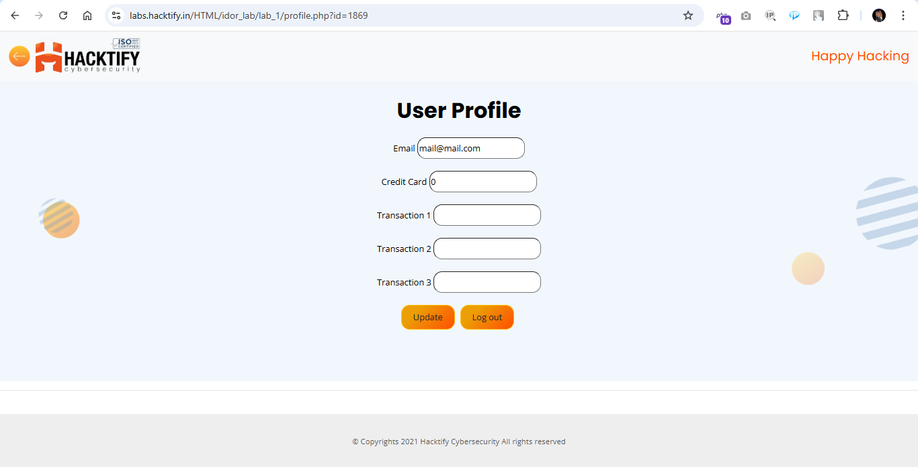
    - Stop polluting my params!

Reference | Risk Rating
Stop polluting my params! | Medium
Tools Used
Google chrome
Vulnerability Description
An insecure direct object reference (IDOR) is an access control vulnerability where invalidated user input can be used for unauthorized access to resources or operations. It occurs when an attacker gains direct access by using user supplied input to an object that has no authorization to access. Attackers can bypass the authorization mechanism to access resources in the system directly by exploiting this vulnerability. Every resource instance can be called as an object and often represented with an ID. And if these IDs are easy enough to guess or an object can be used by an attacker to bypass access check somehow, we can talk about an IDOR at this point.
How It Was Discovered
I found this vulnerability by manipulating value of id parameter in the URL.
Vulnerable URLs
https://labs.hacktify.in/HTML/idor_lab/lab_2/profile.php?id=1327
Consequences of not Fixing the Issue
This vulnerability violates the privacy of a User.
Suggested Countermeasures
- Developers should avoid displaying private object references such as keys or file names.
- Validation of parameters should be properly implemented.
- Verification of all the referenced objects should be checked.
- Tokens should be generated in such a way that they can only be mapped to the user and is not public.
References
- https://portswigger.net/web-security/access-control/idor
- https://cheatsheetseries.owasp.org/cheatsheets/Insecure_Direct_Object_Reference_Prevention_Cheat_Sheet.html
- https://www.bugcrowd.com/blog/how-to-find-idor-insecure-direct-object-reference-vulnerabilities-for-large-bounty-rewards/
Payload Used
Appending “?id=1327” at last in the URL

Proof of Concept

This section contains the proof of the above vulnerabilities as the screenshot of the vulnerability of the lab

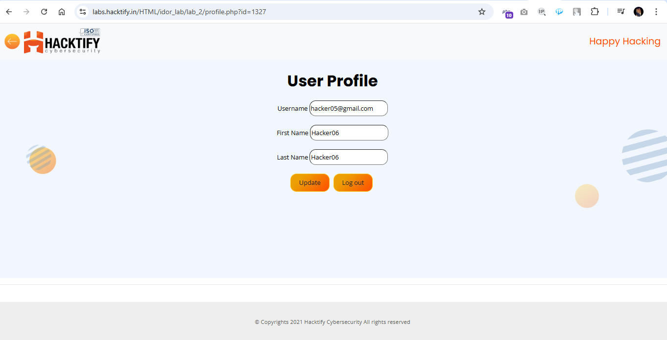
    - Someone changed my Password!

Reference | Risk Rating
Someone changed my Password! | High
Tools Used
Google chrome
Vulnerability Description
An insecure direct object reference (IDOR) is an access control vulnerability where invalidated user input can be used for unauthorized access to resources or operations. It occurs when an attacker gains direct access by using user supplied input to an object that has no authorization to access. Attackers can bypass the authorization mechanism to access resources in the system directly by exploiting this vulnerability. Every resource instance can be called as an object and often represented with an ID. And if these IDs are easy enough to guess or an object can be used by an attacker to bypass access check somehow, we can talk about an IDOR at this point.
How It Was Discovered
I found this vulnerability by manipulating the value of username parameter in the URL.
Vulnerable URLs
https://labs.hacktify.in/HTML/idor_lab/lab_3/changepassword.php?username=hacker
Consequences of not Fixing the Issue
This vulnerability violates the privacy of a User.
Suggested Countermeasures
- Developers should avoid displaying private object references such as keys or file names.
- Validation of parameters should be properly implemented.
- Verification of all the referenced objects should be checked.
- Tokens should be generated in such a way that they can only be mapped to the user and is not public.
References
- https://portswigger.net/web-security/access-control/idor
- https://cheatsheetseries.owasp.org/cheatsheets/Insecure_Direct_Object_Reference_Prevention_Cheat_Sheet.html
- https://www.bugcrowd.com/blog/how-to-find-idor-insecure-direct-object-reference-vulnerabilities-for-large-bounty-rewards/
Payload Used
Appending “?username=hacker” at last in the URL

Proof of Concept

This section contains the proof of the above vulnerabilities as the screenshot of the vulnerability of the lab

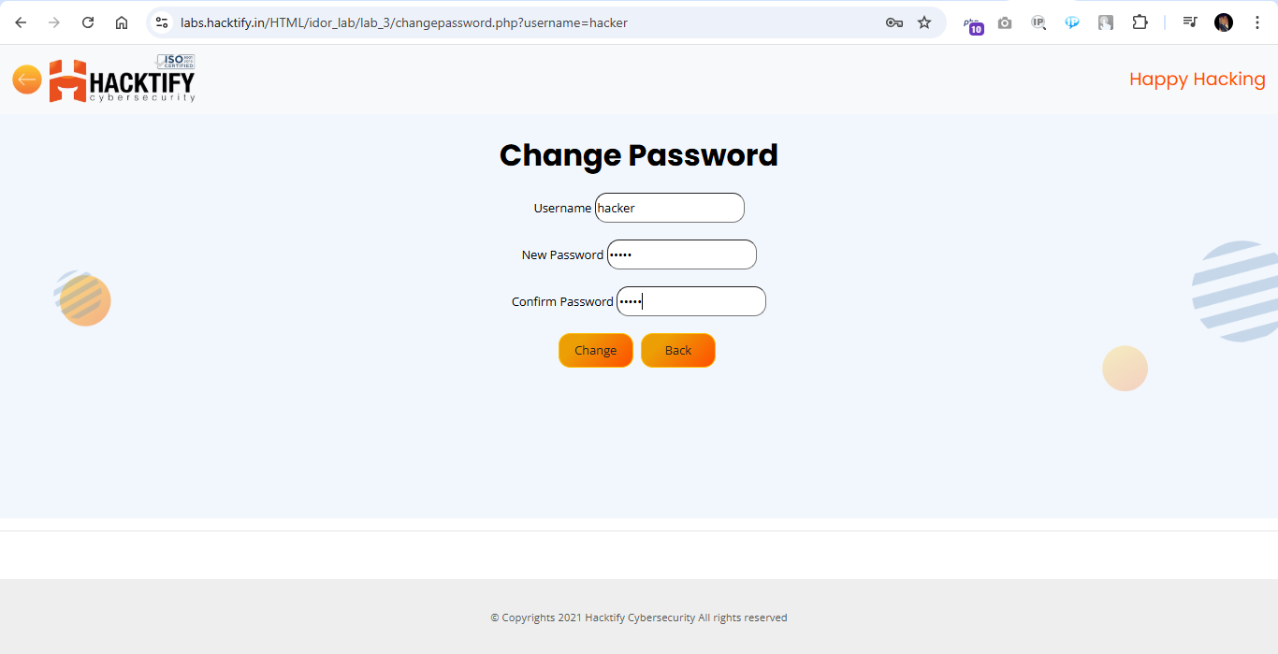
    - Change your methods!

Reference | Risk Rating
Change your methods! | Medium
Tools Used
Google chrome
Vulnerability Description
An insecure direct object reference (IDOR) is an access control vulnerability where invalidated user input can be used for unauthorized access to resources or operations. It occurs when an attacker gains direct access by using user supplied input to an object that has no authorization to access. Attackers can bypass the authorization mechanism to access resources in the system directly by exploiting this vulnerability. Every resource instance can be called as an object and often represented with an ID. And if these IDs are easy enough to guess or an object can be used by an attacker to bypass access check somehow, we can talk about an IDOR at this point.
How It Was Discovered
I found this vulnerability by manipulating the value of id parameter in the URL followed by updating random details in the profile section of different user.
Vulnerable URLs
https://labs.hacktify.in/HTML/idor_lab/lab_4/lab_4.php?email=Ram2%40gmail.com&pwd=abcd&submit=
Consequences of not Fixing the Issue
This vulnerability violates the privacy of a User.
Suggested Countermeasures
- Developers should avoid displaying private object references such as keys or file names.
- Validation of parameters should be properly implemented.
- Verification of all the referenced objects should be checked.
- Tokens should be generated in such a way that they can only be mapped to the user and is not public.
References
- https://portswigger.net/web-security/access-control/idor
- https://cheatsheetseries.owasp.org/cheatsheets/Insecure_Direct_Object_Reference_Prevention_Cheat_Sheet.html
- https://www.bugcrowd.com/blog/how-to-find-idor-insecure-direct-object-reference-vulnerabilities-for-large-bounty-rewards/
Payload Used
Appending “?id=2157” at last in the URL followed by updating random details in the profile section of different user.

Proof of Concept

This section contains the proof of the above vulnerabilities as the screenshot of the vulnerability of the lab

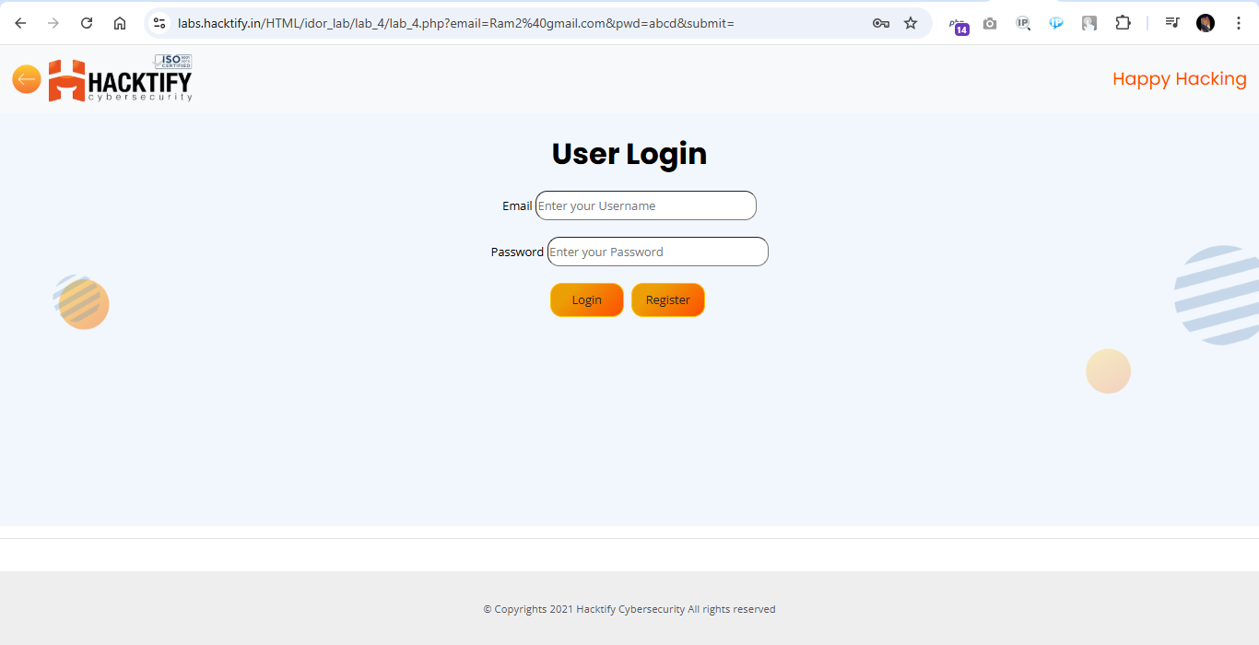
  - SQL Injection
    - Strings and Errors Part1!

Reference | Risk Rating
Strings and Errors Part1! | Low
Tools Used
Google chrome
Vulnerability Description
SQL Injection allows an attacker to view data that attackers are normally not able to retrieve. Data can be information about users, their credentials, personal details etc. It is the process of inserting or injecting SQL queries through input fields to an application to give the hacker the data he wants! Attackers can modify or delete this data causing persistent changes to the application's content or behavior. SQL Injection can also be escalated to compromise the underlying server (or) other back-end infrastructure, or perform a denial-of-service attack
How It Was Discovered
I found this vulnerability by injecting malicious SQL injection code into user input fields, i.e., Email and Password.
Vulnerable URLs
https://labs.hacktify.in/HTML/sqli_lab/lab_1/lab_1.php
Consequences of not Fixing the Issue
Stealing credentials, access to the database, altering or modifying data, access to the network.
Suggested Countermeasures
- Implement Input Validation and Sanitization
- Using Escaping for User Input
- Utilize Parameterized Statements (Prepared Statements)
- Incorporate Stored Procedures
- Conduct Continuous Scanning and Penetration Testing
- Adopt the Least Privilege Principle
- Deploy Web Application Firewalls (WAF)
References
- https://portswigger.net/web-security/sql-injection/cheat-sheet
- https://portswigger.net/web-security/sql-injection
- https://owasp.org/www-community/attacks/SQL_Injection
Payload Used
In both the user input fields insert below payload and click login
1" OR "1"="1

Proof of Concept

This section contains the proof of the above vulnerabilities as the screenshot of the vulnerability of the lab

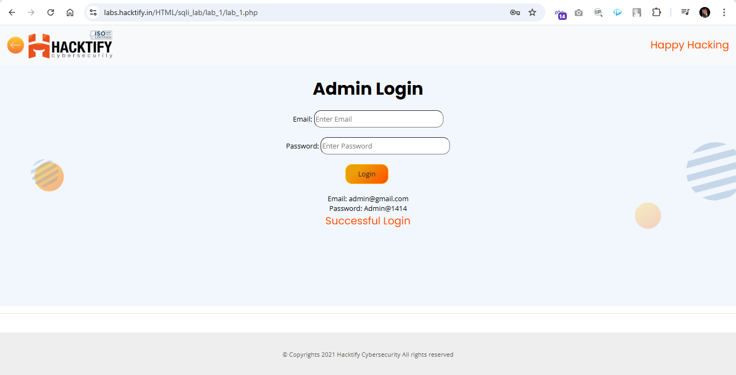
2.2. Strings and Errors Part2!

Reference | Risk Rating
Strings and Errors Part2! | Low
Tools Used
Google chrome
Vulnerability Description
SQL Injection allows an attacker to view data that attackers are normally not able to retrieve. Data can be information about users, their credentials, personal details etc. It is the process of inserting or injecting SQL queries through input fields to an application to give the hacker the data he wants! Attackers can modify or delete this data causing persistent changes to the application's content or behavior. SQL Injection can also be escalated to compromise the underlying server (or) other back-end infrastructure, or perform a denial-of-service attack
How It Was Discovered
I found this vulnerability by injecting malicious SQL injection code into the URL.
Vulnerable URLs
https://labs.hacktify.in/HTML/sqli_lab/lab_2/lab_2.php?id=3%22%20OR%20%221%22=%221%20
Consequences of not Fixing the Issue
Stealing credentials, access to the database, altering or modifying data, access to the network.
Suggested Countermeasures
- Implement Input Validation and Sanitization
- Using Escaping for User Input
- Utilize Parameterized Statements (Prepared Statements)
- Incorporate Stored Procedures
- Conduct Continuous Scanning and Penetration Testing
- Adopt the Least Privilege Principle
- Deploy Web Application Firewalls (WAF)
References
- https://portswigger.net/web-security/sql-injection/cheat-sheet
- https://portswigger.net/web-security/sql-injection
- https://owasp.org/www-community/attacks/SQL_Injection
Payload Used
Appending below payload at last in the URL
?id=3"%20OR%20"1"="1%20

Proof of Concept

This section contains the proof of the above vulnerabilities as the screenshot of the vulnerability of the lab

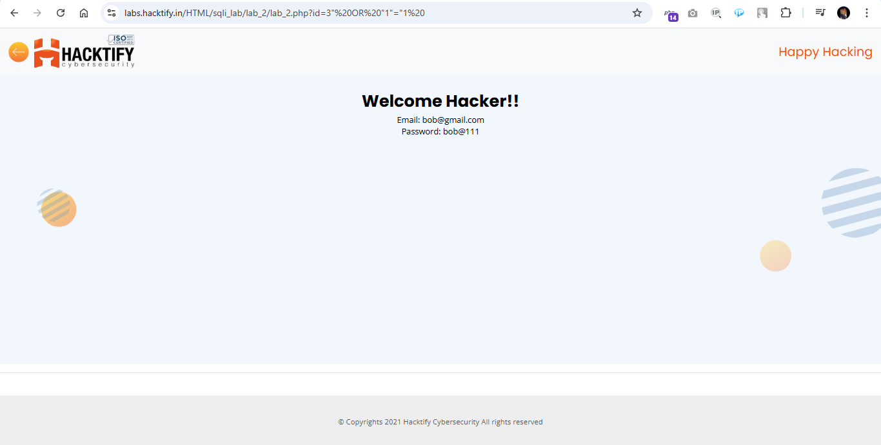
2.3. Strings and Errors Part3!

Reference | Risk Rating
Strings and Errors Part3! | Low
Tools Used
Google chrome
Vulnerability Description
SQL Injection allows an attacker to view data that attackers are normally not able to retrieve. Data can be information about users, their credentials, personal details etc. It is the process of inserting or injecting SQL queries through input fields to an application to give the hacker the data he wants! Attackers can modify or delete this data causing persistent changes to the application's content or behavior. SQL Injection can also be escalated to compromise the underlying server (or) other back-end infrastructure, or perform a denial-of-service attack
How It Was Discovered
I found this vulnerability by injecting malicious SQL injection code into the URL.
Vulnerable URLs
https://labs.hacktify.in/HTML/sqli_lab/lab_3/lab_3.php?id=1%22%20OR%20%221%22=%221%20
Consequences of not Fixing the Issue
Stealing credentials, access to the database, altering or modifying data, access to the network.
Suggested Countermeasures
- Implement Input Validation and Sanitization
- Using Escaping for User Input
- Utilize Parameterized Statements (Prepared Statements)
- Incorporate Stored Procedures
- Conduct Continuous Scanning and Penetration Testing
- Adopt the Least Privilege Principle
- Deploy Web Application Firewalls (WAF)
References
- https://portswigger.net/web-security/sql-injection/cheat-sheet
- https://portswigger.net/web-security/sql-injection
- https://owasp.org/www-community/attacks/SQL_Injection
Payload Used
Appending below payload at last in the URL
?id=3" OR "1"="1

Proof of Concept

This section contains the proof of the above vulnerabilities as the screenshot of the vulnerability of the lab

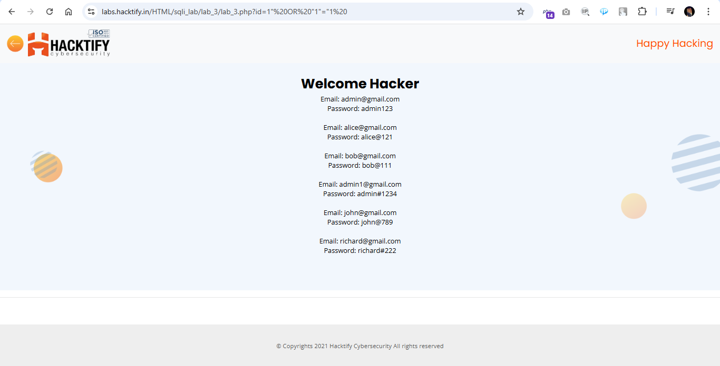
2.4. Let’s Trick ‘em!

Reference | Risk Rating
Let’s Trick ‘em! | Medium
Tools Used
Google chrome
Vulnerability Description
SQL Injection allows an attacker to view data that attackers are normally not able to retrieve. Data can be information about users, their credentials, personal details etc. It is the process of inserting or injecting SQL queries through input fields to an application to give the hacker the data he wants! Attackers can modify or delete this data causing persistent changes to the application's content or behavior. SQL Injection can also be escalated to compromise the underlying server (or) other back-end infrastructure, or perform a denial-of-service attack
How It Was Discovered
I found this vulnerability by injecting malicious SQL injection code into user input fields, i.e., Email and Password.
Vulnerable URLs
https://labs.hacktify.in/HTML/sqli_lab/lab_4/lab_4.php
Consequences of not Fixing the Issue
Stealing credentials, access to the database, altering or modifying data, access to the network.
Suggested Countermeasures
- Implement Input Validation and Sanitization
- Using Escaping for User Input
- Utilize Parameterized Statements (Prepared Statements)
- Incorporate Stored Procedures
- Conduct Continuous Scanning and Penetration Testing
- Adopt the Least Privilege Principle
- Deploy Web Application Firewalls (WAF)
References
- https://portswigger.net/web-security/sql-injection/cheat-sheet
- https://portswigger.net/web-security/sql-injection
- https://owasp.org/www-community/attacks/SQL_Injection
Payload Used
In both the user input fields insert below payload and click login
1' || '1'= '1

Proof of Concept

This section contains the proof of the above vulnerabilities as the screenshot of the vulnerability of the lab

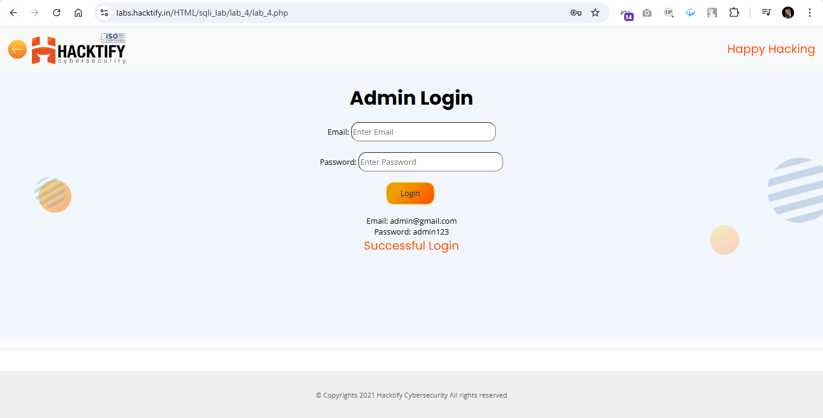
2.5. Booleans and Blind!

Reference | Risk Rating
Booleans and Blind! | High
Tools Used
Google chrome
Vulnerability Description
SQL Injection allows an attacker to view data that attackers are normally not able to retrieve. Data can be information about users, their credentials, personal details etc. It is the process of inserting or injecting SQL queries through input fields to an application to give the hacker the data he wants! Attackers can modify or delete this data causing persistent changes to the application's content or behavior. SQL Injection can also be escalated to compromise the underlying server (or) other back-end infrastructure, or perform a denial-of-service attack
How It Was Discovered
I found this vulnerability by injecting malicious SQL injection code into the URL.
Vulnerable URLs
https://labs.hacktify.in/HTML/sqli_lab/lab_5/lab_5.php?id=3%22%20AND%20%221%22=%221%22
Consequences of not Fixing the Issue
Stealing credentials, access to the database, altering or modifying data, access to the network.
Suggested Countermeasures
- Implement Input Validation and Sanitization
- Using Escaping for User Input
- Utilize Parameterized Statements (Prepared Statements)
- Incorporate Stored Procedures
- Conduct Continuous Scanning and Penetration Testing
- Adopt the Least Privilege Principle
- Deploy Web Application Firewalls (WAF)
References
- https://portswigger.net/web-security/sql-injection/cheat-sheet
- https://portswigger.net/web-security/sql-injection
- https://owasp.org/www-community/attacks/SQL_Injection
Payload Used
Appending below payload at last in the URL
?id=3" OR "1"="1

Proof of Concept

This section contains the proof of the above vulnerabilities as the screenshot of the vulnerability of the lab

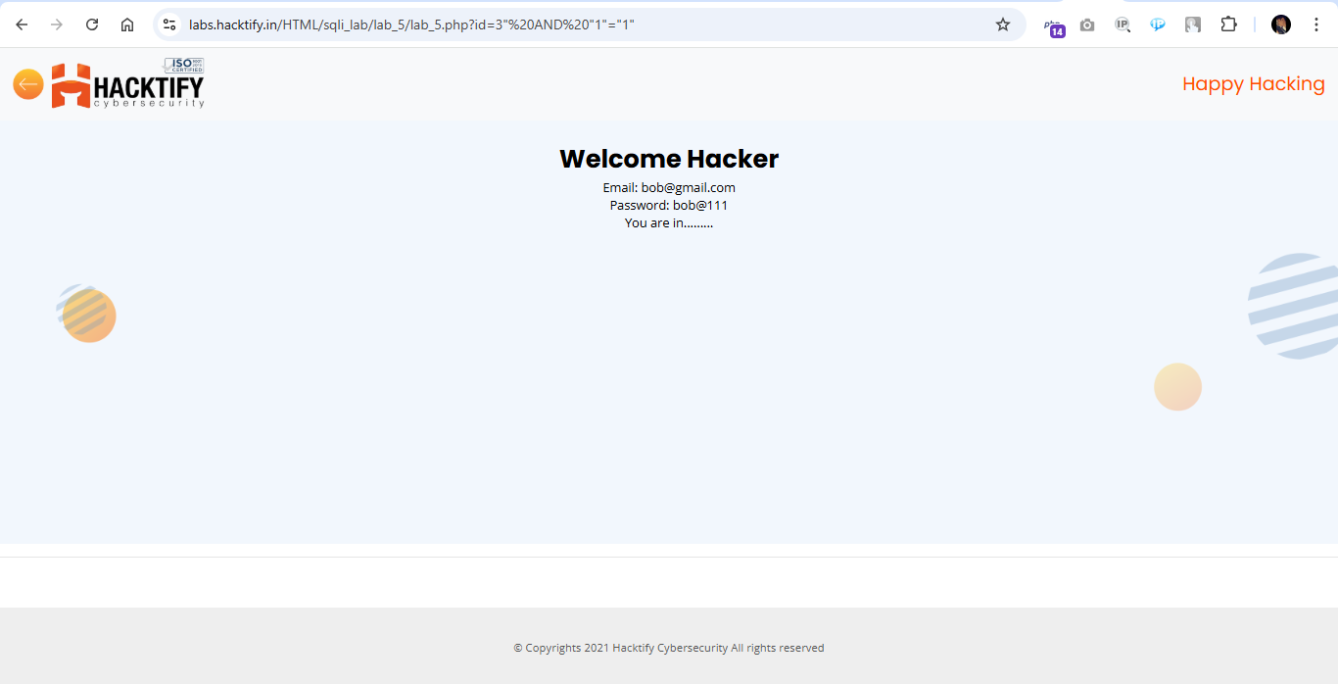

2.6. Error based: Tricked

Reference | Risk Rating
Error based: Tricked | Medium
Tools Used
Google chrome
Vulnerability Description
SQL Injection allows an attacker to view data that attackers are normally not able to retrieve. Data can be information about users, their credentials, personal details etc. It is the process of inserting or injecting SQL queries through input fields to an application to give the hacker the data he wants! Attackers can modify or delete this data causing persistent changes to the application's content or behavior. SQL Injection can also be escalated to compromise the underlying server (or) other back-end infrastructure, or perform a denial-of-service attack
How It Was Discovered
I found this vulnerability by injecting malicious SQL injection code into user input fields, i.e., Email and Password.
Vulnerable URLs
https://labs.hacktify.in/HTML/sqli_lab/lab_6/lab_6.php
Consequences of not Fixing the Issue
Stealing credentials, access to the database, altering or modifying data, access to the network.
Suggested Countermeasures
- Implement Input Validation and Sanitization
- Using Escaping for User Input
- Utilize Parameterized Statements (Prepared Statements)
- Incorporate Stored Procedures
- Conduct Continuous Scanning and Penetration Testing
- Adopt the Least Privilege Principle
- Deploy Web Application Firewalls (WAF)
References
- https://portswigger.net/web-security/sql-injection/cheat-sheet
- https://portswigger.net/web-security/sql-injection
- https://owasp.org/www-community/attacks/SQL_Injection
Payload Used
In both the user input fields insert below payload and click login
") or ("1")=("1

Proof of Concept

This section contains the proof of the above vulnerabilities as the screenshot of the vulnerability of the lab

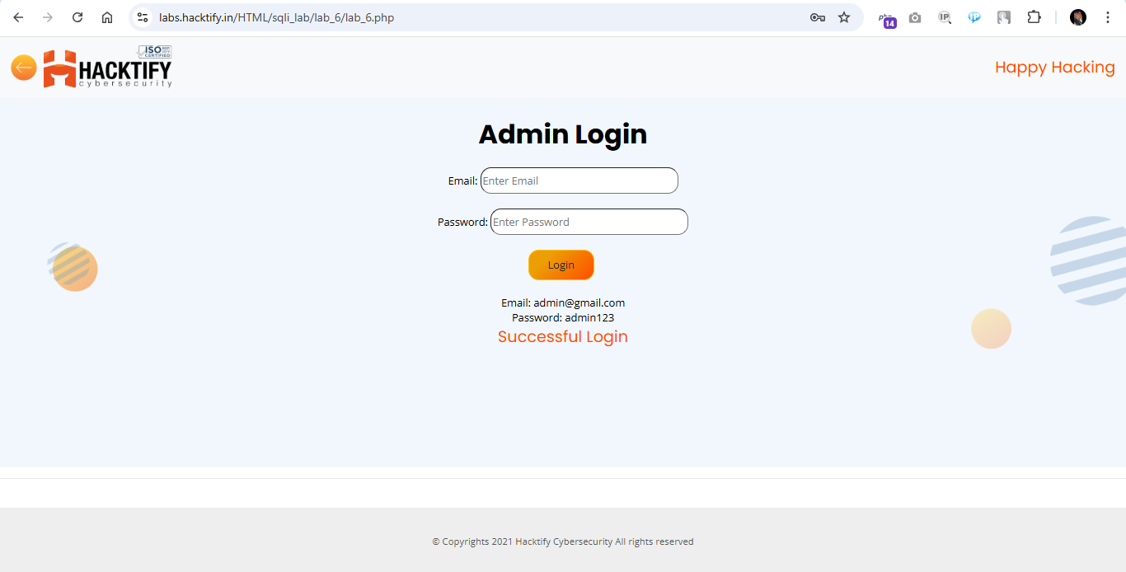

2.7. Errors and Post!

Reference | Risk Rating
Errors and Post! | Low
Tools Used
Google chrome
Vulnerability Description
SQL Injection allows an attacker to view data that attackers are normally not able to retrieve. Data can be information about users, their credentials, personal details etc. It is the process of inserting or injecting SQL queries through input fields to an application to give the hacker the data he wants! Attackers can modify or delete this data causing persistent changes to the application's content or behavior. SQL Injection can also be escalated to compromise the underlying server (or) other back-end infrastructure, or perform a denial-of-service attack
How It Was Discovered
I found this vulnerability by injecting malicious SQL injection code into user input fields, i.e., Email and Password.
Vulnerable URLs
https://labs.hacktify.in/HTML/sqli_lab/lab_7/lab_7.php
Consequences of not Fixing the Issue
Stealing credentials, access to the database, altering or modifying data, access to the network.
Suggested Countermeasures
- Implement Input Validation and Sanitization
- Using Escaping for User Input
- Utilize Parameterized Statements (Prepared Statements)
- Incorporate Stored Procedures
- Conduct Continuous Scanning and Penetration Testing
- Adopt the Least Privilege Principle
- Deploy Web Application Firewalls (WAF)
References
- https://portswigger.net/web-security/sql-injection/cheat-sheet
- https://portswigger.net/web-security/sql-injection
- https://owasp.org/www-community/attacks/SQL_Injection
Payload Used
In both the user input fields insert below payload and click login
' or '1'='1

Proof of Concept

This section contains the proof of the above vulnerabilities as the screenshot of the vulnerability of the lab

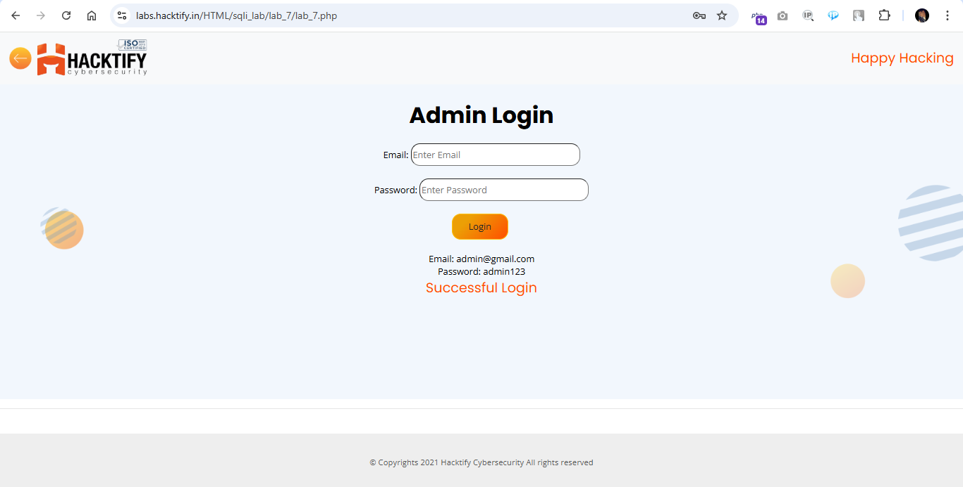

2.8. User Agents lead us!

Reference | Risk Rating
User Agents lead us! | High
Tools Used
Google chrome and Burp suite
Vulnerability Description
SQL Injection allows an attacker to view data that attackers are normally not able to retrieve. Data can be information about users, their credentials, personal details etc. It is the process of inserting or injecting SQL queries through input fields to an application to give the hacker the data he wants! Attackers can modify or delete this data causing persistent changes to the application's content or behavior. SQL Injection can also be escalated to compromise the underlying server (or) other back-end infrastructure, or perform a denial-of-service attack
How It Was Discovered
I found this vulnerability by injecting malicious SQL injection code into user agent field by intercepting login request into Burp Suite.
Vulnerable URLs
https://labs.hacktify.in/HTML/sqli_lab/lab_8/lab_8.php
Consequences of not Fixing the Issue
Stealing credentials, access to the database, altering or modifying data, access to the network.
Suggested Countermeasures
- Implement Input Validation and Sanitization
- Using Escaping for User Input
- Utilize Parameterized Statements (Prepared Statements)
- Incorporate Stored Procedures
- Conduct Continuous Scanning and Penetration Testing
- Adopt the Least Privilege Principle
- Deploy Web Application Firewalls (WAF)
References
- https://portswigger.net/web-security/sql-injection/cheat-sheet
- https://portswigger.net/web-security/sql-injection
- https://owasp.org/www-community/attacks/SQL_Injection
Payload Used
Login with Admin credentials obtained in previous labs, Intercept the traffic with Burpsuite, In the User Agent field insert the below payload
" AND 1=1 #

Proof of Concept

This section contains the proof of the above vulnerabilities as the screenshot of the vulnerability of the lab

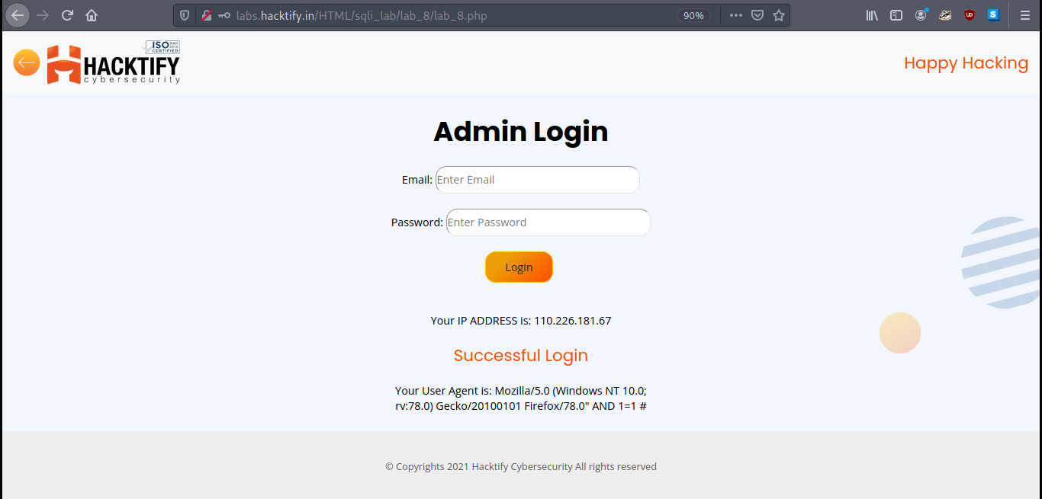

2.9. Referer lead us!

Reference | Risk Rating
Referer lead us! | Medium
Tools Used
Google chrome and Burp suite
Vulnerability Description
SQL Injection allows an attacker to view data that attackers are normally not able to retrieve. Data can be information about users, their credentials, personal details etc. It is the process of inserting or injecting SQL queries through input fields to an application to give the hacker the data he wants! Attackers can modify or delete this data causing persistent changes to the application's content or behavior. SQL Injection can also be escalated to compromise the underlying server (or) other back-end infrastructure, or perform a denial-of-service attack
How It Was Discovered
I found this vulnerability by injecting malicious SQL injection code into referrer field by intercepting login request into Burp Suite.
Vulnerable URLs
https://labs.hacktify.in/HTML/sqli_lab/lab_9/lab_9.php
Consequences of not Fixing the Issue
Stealing credentials, access to the database, altering or modifying data, access to the network.
Suggested Countermeasures
- Implement Input Validation and Sanitization
- Using Escaping for User Input
- Utilize Parameterized Statements (Prepared Statements)
- Incorporate Stored Procedures
- Conduct Continuous Scanning and Penetration Testing
- Adopt the Least Privilege Principle
- Deploy Web Application Firewalls (WAF)
References
- https://portswigger.net/web-security/sql-injection/cheat-sheet
- https://portswigger.net/web-security/sql-injection
- https://owasp.org/www-community/attacks/SQL_Injection
Payload Used
Login with Admin credentials obtained in previous labs, Intercept the traffic with Burpsuite, In the Referer field insert the below payload
' OR '1'='1 #

Proof of Concept

This section contains the proof of the above vulnerabilities as the screenshot of the vulnerability of the lab

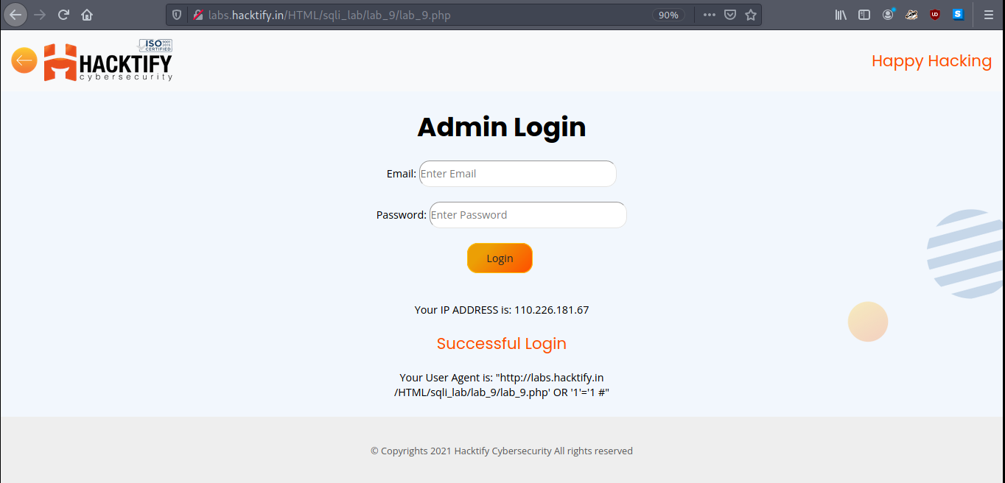

2.10. Oh Cookies!

Reference | Risk Rating
Oh Cookies! | High
Tools Used
Google chrome
Vulnerability Description
SQL Injection allows an attacker to view data that attackers are normally not able to retrieve. Data can be information about users, their credentials, personal details etc. It is the process of inserting or injecting SQL queries through input fields to an application to give the hacker the data he wants! Attackers can modify or delete this data causing persistent changes to the application's content or behavior. SQL Injection can also be escalated to compromise the underlying server (or) other back-end infrastructure, or perform a denial-of-service attack
How It Was Discovered
I found this vulnerability by injecting malicious SQL injection code into cookie value by inspecting the cookie settings after logging into the sign in page.
Vulnerable URLs
https://labs.hacktify.in/HTML/sqli_lab/lab_10/lab_10.php
Consequences of not Fixing the Issue
Stealing credentials, access to the database, altering or modifying data, access to the network.
Suggested Countermeasures
- Implement Input Validation and Sanitization
- Using Escaping for User Input
- Utilize Parameterized Statements (Prepared Statements)
- Incorporate Stored Procedures
- Conduct Continuous Scanning and Penetration Testing
- Adopt the Least Privilege Principle
- Deploy Web Application Firewalls (WAF)
References
- https://portswigger.net/web-security/sql-injection/cheat-sheet
- https://portswigger.net/web-security/sql-injection
- https://owasp.org/www-community/attacks/SQL_Injection
Payload Used
Login with Admin credentials, click on Inspect and go to the Cookies section and insert the below payload into Username field
1" OR "1"="1

Proof of Concept

This section contains the proof of the above vulnerabilities as the screenshot of the vulnerability of the lab

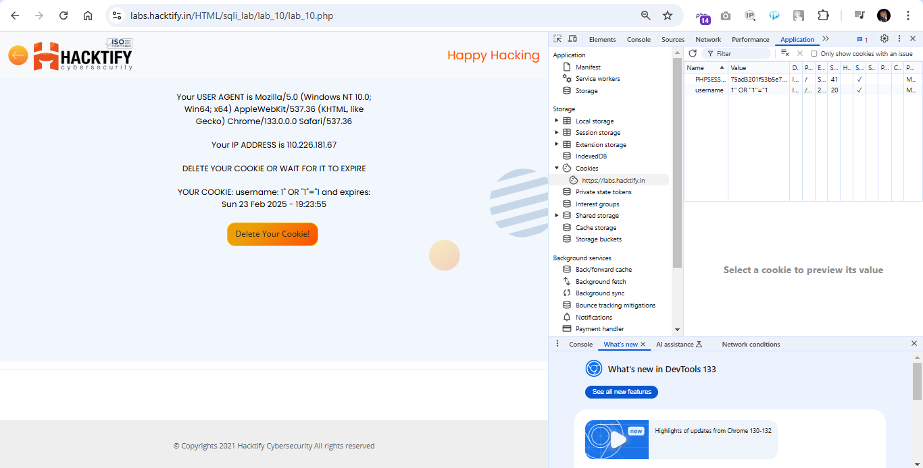

2.11. WAF’s Are injected!

Reference | Risk Rating
WAF’s Are injected! | High
Tools Used
Google chrome
Vulnerability Description
SQL Injection allows an attacker to view data that attackers are normally not able to retrieve. Data can be information about users, their credentials, personal details etc. It is the process of inserting or injecting SQL queries through input fields to an application to give the hacker the data he wants! Attackers can modify or delete this data causing persistent changes to the application's content or behavior. SQL Injection can also be escalated to compromise the underlying server (or) other back-end infrastructure, or perform a denial-of-service attack
How It Was Discovered
I found this vulnerability by injecting malicious SQL injection code into the URL.
Vulnerable URLs
https://labs.hacktify.in/HTML/sqli_lab/lab_11/lab_11.php?id=4
Consequences of not Fixing the Issue
Stealing credentials, access to the database, altering or modifying data, access to the network.
Suggested Countermeasures
- Implement Input Validation and Sanitization
- Using Escaping for User Input
- Utilize Parameterized Statements (Prepared Statements)
- Incorporate Stored Procedures
- Conduct Continuous Scanning and Penetration Testing
- Adopt the Least Privilege Principle
- Deploy Web Application Firewalls (WAF)
References
- https://portswigger.net/web-security/sql-injection/cheat-sheet
- https://portswigger.net/web-security/sql-injection
- https://owasp.org/www-community/attacks/SQL_Injection
Payload Used
Appending below payload at last in the URL
?id=4

Proof of Concept

This section contains the proof of the above vulnerabilities as the screenshot of the vulnerability of the lab

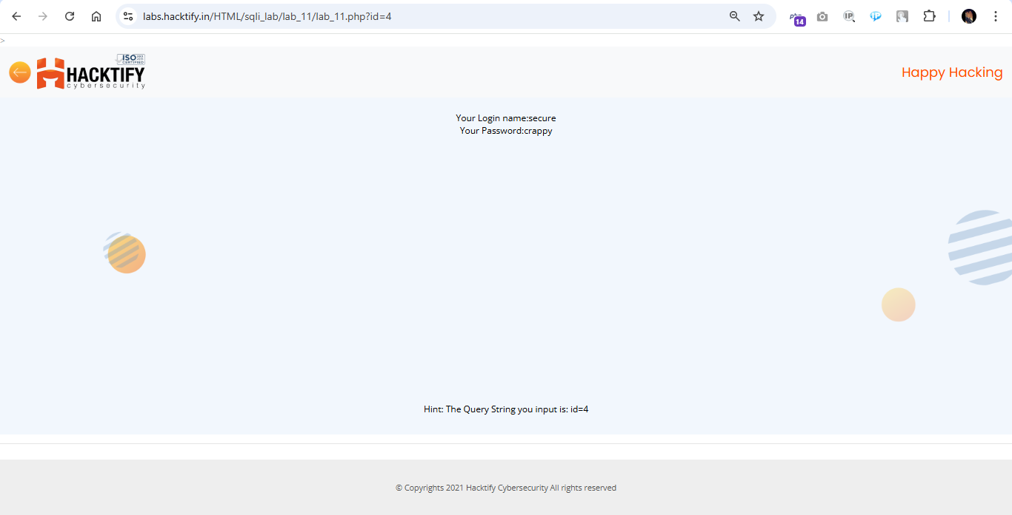

2.12. WAF’s Are injected Part2!
Reference | Risk Rating
WAF’s Are injected Part2! | Medium
Tools Used
Google chrome
Vulnerability Description
SQL Injection allows an attacker to view data that attackers are normally not able to retrieve. Data can be information about users, their credentials, personal details etc. It is the process of inserting or injecting SQL queries through input fields to an application to give the hacker the data he wants! Attackers can modify or delete this data causing persistent changes to the application's content or behavior. SQL Injection can also be escalated to compromise the underlying server (or) other back-end infrastructure, or perform a denial-of-service attack
How It Was Discovered
I found this vulnerability by injecting malicious SQL injection code into the URL.
Vulnerable URLs
https://labs.hacktify.in/HTML/sqli_lab/lab_12/lab_12.php?id=8
Consequences of not Fixing the Issue
Stealing credentials, access to the database, altering or modifying data, access to the network.
Suggested Countermeasures
- Implement Input Validation and Sanitization
- Using Escaping for User Input
- Utilize Parameterized Statements (Prepared Statements)
- Incorporate Stored Procedures
- Conduct Continuous Scanning and Penetration Testing
- Adopt the Least Privilege Principle
- Deploy Web Application Firewalls (WAF)
References
- https://portswigger.net/web-security/sql-injection/cheat-sheet
- https://portswigger.net/web-security/sql-injection
- https://owasp.org/www-community/attacks/SQL_Injection
Payload Used
Appending below payload at last in the URL
?id=8

Proof of Concept

This section contains proof of the above vulnerabilities as the screenshot of the vulnerability of the lab.

